Step 1:- Open the Loadrunner Controller.

Step 2:- Browse the Script using browse button and select options as shown and click ok.

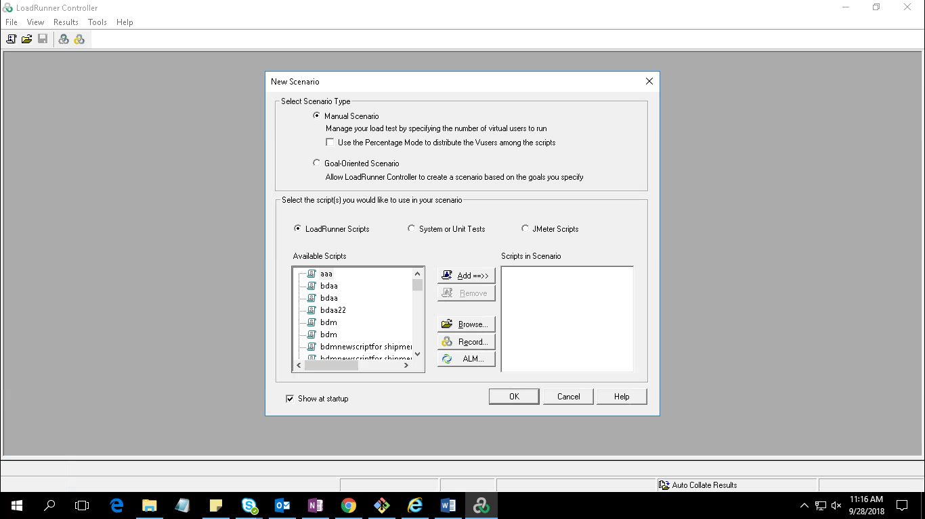

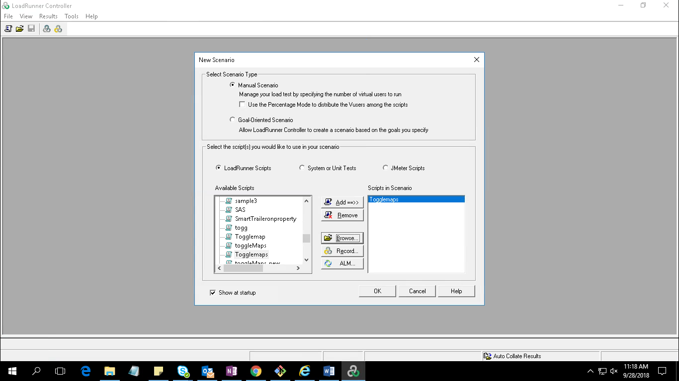

Step3:-Select Basic Schedule and give number of users in quantity as shown

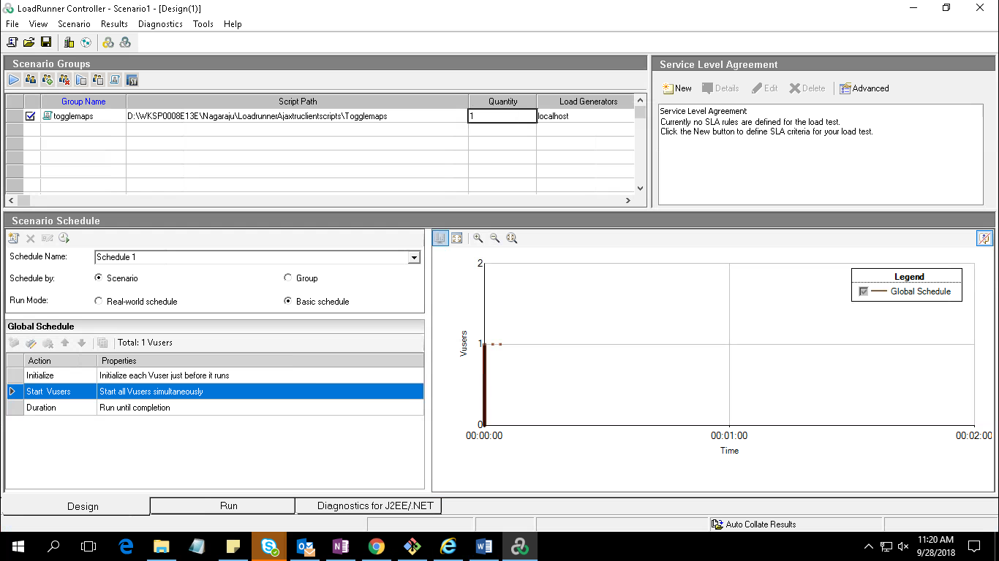

Step4:- select duration and give time in run for

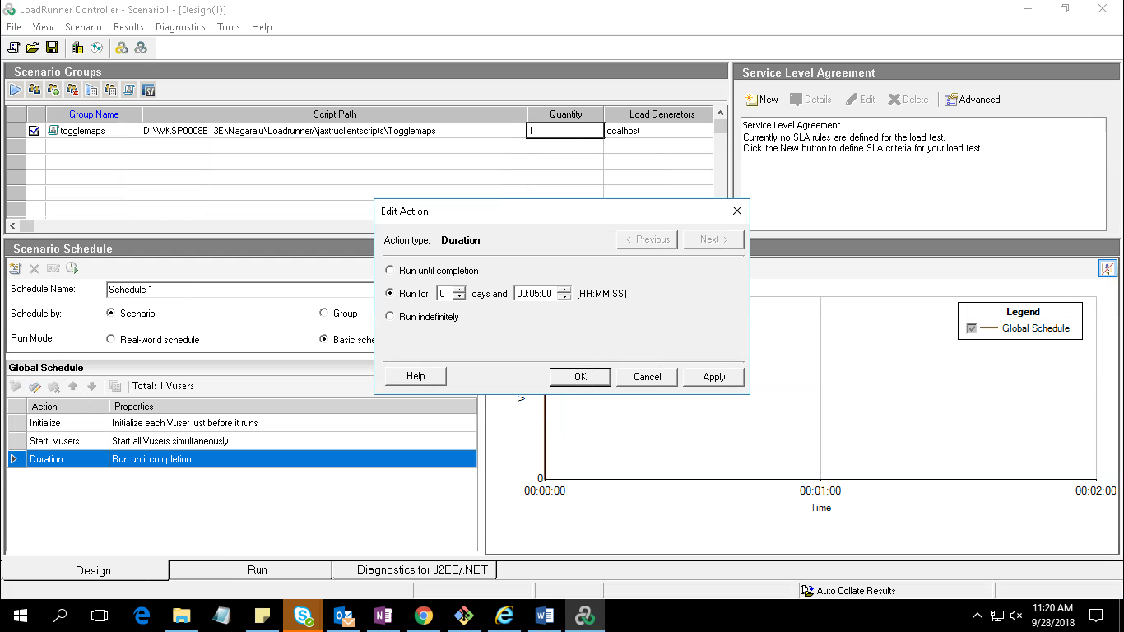

Step5:- Clcik on Results -🡪Results setting give results directory name and click ok

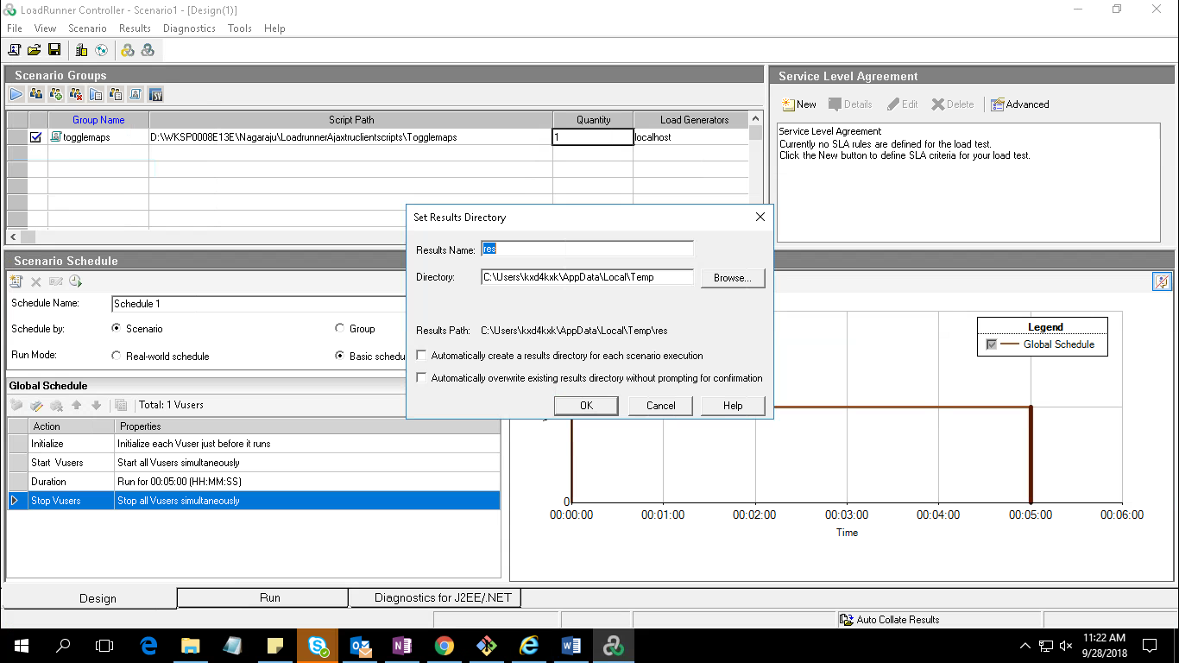

Step6:-Then go to Run tab and click on start scenario button.

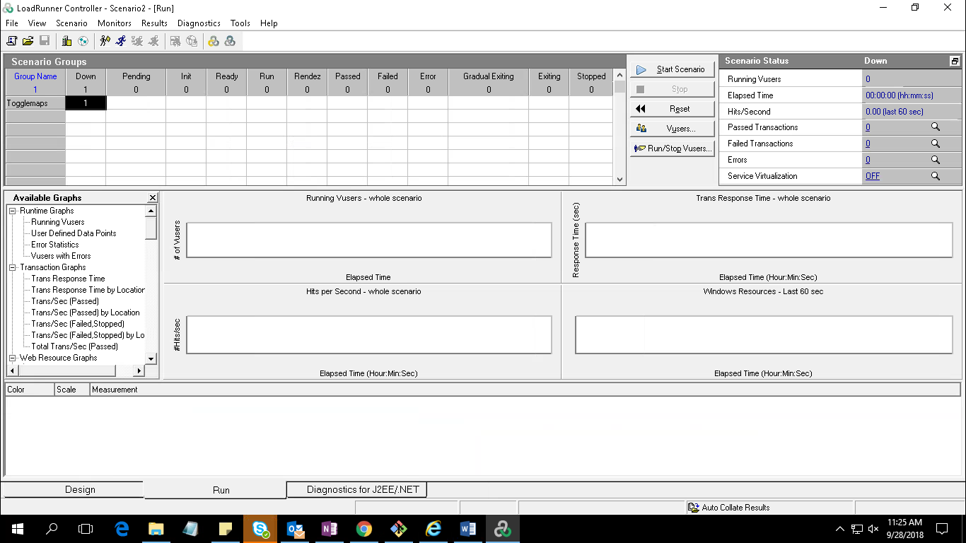

Once test completes results will correlate.